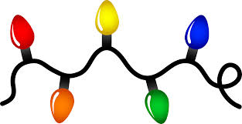
CREATE A MUSICAL PERFORMANCE!
(USING LIGHT AND SOUND)

Design Brief/Introduction:
This is an open-ended challenge. As a group, you are required to use musical instruments and light materials to create a performance to present to the class, your teacher and parents/guardians.

Step One:
Investigate the materials provided by Miss Nero and consider what are the best musical instruments and light materials your group would like to use.

Step Two:
- Choose the allocated materials needed and plan your performance.
- State in your group science journal why you chose the musical instruments and light materials.

Materials:
Your group MUST include
- Three (3) musical instruments
- Two (2) light materials

Step Three:
- Practice your performance.
Time Allocation:
40 minutes
Step Five:
Arrange a time with Miss Nero to organise an appropriate time to perform in front of an audience.

Step Four:
After your performance, write a reflection on what was successful and what needs improving.

